Virtual Event Management Platform

Department of Computer Information Systems

College of Computer Science & Information Technology

Group C

1. **Introduction:**
   1. **Purpose**

This document's goal is to lay out the specifications needed to create a virtual event management platform referred to as "the system." With this platform, hosts, organizers, and attendees will have a comprehensive solution for planning, organizing, and carrying out virtual events.

* 1. **Document Convention**

This publication uses IEEE as its citation format. Subheadings are bolded with size 14 and the heads are written in size 18. The two are bolded. Size 12 points is the body content setting. The Times New Roman font type is used throughout the entire document.

* 1. **Intended Audience and Reading Suggestions**

**Intended Audience:**

* Instructors
* Project managers
* Users
* Employees
* Administrators

**Reading Suggestions:**

As indicated by the table of contents, we advise reading the document in that sequence.

* 1. **Product Scope**

A host of capabilities, including live streaming, interactive sessions, networking possibilities, analytics, event design, attendee registration, virtual venue setup, and more, will be included in the Virtual Event Management Platform. Numerous virtual events will be supported by it, such as webinars, seminars, trade exhibits, and social gatherings.

* 1. **References**
* [1] chrome-extension://efaidnbmnnnibpcajpcglclefindmkaj/https://www.researchgate.net/profile/Asmahany-Ramely/publication/356909917_Virtual_is_Vital_The_Strategies_Design_and_Attendee_Engagement_of_Virtual_Events/links/61b239784baa6511981764b9/Virtual-is-Vital-The-Strategies-Design-and-Attendee-Engagement-of-Virtual-Events.pdf
* [2]SAAD book

1. **Overall Description**
   1. **Product Perspective**

The Virtual Event Management Platform (VEMP) serves as an innovative solution to meet the evolving demands of virtual event planning and execution. Positioned within the context of the digital era, the VEMP is designed to be a central hub for users seeking to seamlessly navigate the complexities of organizing and participating in virtual events. This platform is conceived not just as a tool but as an ecosystem that fosters meaningful connections and memorable experiences in the virtual realm.

* 1. **Product Functions**

Within the VEMP, a comprehensive set of functions empowers users at every stage of the virtual event lifecycle. Robust planning tools offer event organizers the flexibility to design and customize their events, from scheduling sessions to designing interactive virtual environments. Attendee registration processes are streamlined, while content management features enable organizers to curate engaging sessions. Live streaming capabilities, coupled with audience interaction tools such as live chat and Q&A sessions, ensure dynamic and immersive experiences. Post-event, analytics tools provide valuable insights for organizers to assess performance and gather feedback for future improvements.

* 1. **User Classes and Characteristics**

The VEMP caters to a diverse user base, including seasoned event organizers, corporate planners, individual hosts, and exhibitors. Event organizers benefit from advanced planning features, while hosts find user-friendly tools to manage sessions effectively. Attendees, irrespective of technical expertise, enjoy a seamless registration process and immersive virtual environments. Exhibitors can harness the platform to create tailored virtual booths, engage with visitors, and generate leads. The platform's intuitive design ensures accessibility for users with varying levels of technical proficiency.

* 1. **Operating Environment**

Operational within a cloud-based environment, the VEMP guarantees scalability, reliability, and accessibility. Compatibility with popular web browsers allows users to access the platform across a spectrum of devices, from desktops and laptops to mobile devices. Leveraging cutting-edge technologies, the VEMP delivers smooth live streaming and virtual interaction experiences. Furthermore, integration capabilities with third-party tools enhance adaptability, ensuring compatibility with a variety of event requirements.

* 1. **Design and Implementation Constraints**

While prioritizing user experience and data security, the VEMP has its constraints. Optimal performance relies on stable internet connections and up-to-date web browsers. The platform adheres to industry standards for data encryption and privacy compliance. Scalability is a key focus, but potential limitations may arise based on the user's internet speed and device capabilities.

* 1. **User Documentation**

Comprehensive user documentation accompanies the VEMP, offering guides, video tutorials, and FAQs to assist users in setup, customization, and troubleshooting. Regular updates to the documentation reflect feature enhancements and user feedback, fostering an informed and engaged user community.

* 1. **Assumptions and Dependencies**

The VEMP assumes users possess basic internet literacy and access to stable internet connections. Dependencies include third-party services for payment processing, live streaming, and analytics. Compliance with data protection regulations is assumed, with users encouraged to stay informed about updates and best practices. The platform's success is also dependent on ongoing user engagement and feedback, driving continuous improvements aligned with the evolving needs of the virtual events landscape.

1. **External Interface Requirements**

**3.1 User Interfaces**

* The platform shall provide a web-based graphical user interface (GUI) accessible through standard web browsers.
* The GUI must be responsive and compatible with various devices, including desktop computers, laptops, tablets, and mobile phones.

**3.2 User Registration and Authentication**

* Users shall have the ability to register and create accounts on the s
* The platform must support various methods of authentication, including email/password, social media logins, and single sign-on (SSO).
* Passwords need to be securely hashed and stored.

**3.3 Event Creation and Management**

* Event organizers must have the capability to create and oversee virtual events through the platform.
* The platform should provide tools for configuring event details, schedules, speakers, and sponsors.

**3.4 Attendee Interaction**

* Attendees should be able to register for events, access event details, and participate in virtual sessions and discussions.
* Real-time chat and Q&A features should be available during virtual sessions.
* Polling and engaging the audience should be supported.

**3.5 External APIs**

* The platform must offer a RESTful API for integration with external systems, including customer relationship management (CRM) tools, marketing automation software, and payment gateways.
* API documentation that clearly defines endpoints, request/response formats, and authentication methods should be provided.

**3.6 Data Exchange**

* The platform should facilitate data import and export, allowing event organizers to import participant lists and export event data for analysis.
* Data exchange should use standard formats like CSV and JSON.

**3.7 Video Streaming and Integration**

* The platform needs to seamlessly integrate with third-party video conferencing and streaming services (e.g., Zoom, YouTube Live).
* Video and audio quality should be adjustable based on user bandwidth.

**3.8 Payment Gateway Integration**

* The platform should integrate with payment gateways to enable event registration and ticket sales.
* It should support various payment methods (credit cards, PayPal, etc.).

**3.9 Social Media Integration**

* Users should have the option to share event information and updates on social media platforms.
* Social media login and sharing options should be included.

**3.10 Accessibility and Localization**

* The platform should comply with accessibility standards (e.g., WCAG) to ensure usability for individuals with disabilities.
* Localization features should be available to accommodate multiple languages and regions.

**3.11 Security Requirements**

* The platform must implement robust security measures, including encryption (SSL/TLS), user session management, and protection against common web vulnerabilities (e.g., XSS, CSRF).
* Access controls should be enforced to prevent unauthorized access to event content.

**3.12 Analytics and Reporting**

* Event organizers should have access to analytics and reporting tools for monitoring attendee engagement, session attendance, and other relevant metrics.
* Customizable reports and export options must be provided.

**3.13 Support and Helpdesk Integration**

* The platform should offer customer support features, including ticketing systems and integration with a knowledge base.
* Users should have access to online help resources and FAQs.

1. **System Features**
   1. **Feature: Virtual Event Types**
      1. **Description and Priority:**

Description: The system should support various types of virtual events, such as webinars, conferences, and expos.

Priority: High

* + 1. **Stimulus/Response Sequences:**

Stimulus: The event organizer selects the type of virtual event to host.

Response: The system configures the event environment based on the selected type, providing appropriate features and settings.

* + 1. **Functional Requirements:**

REQ-1: The system must allow event organizers to select from a predefined list of virtual event types.

REQ-2: Event organizers should be able to configure specific features and settings for each selected event type.

REQ-3: Event organizers should have the ability to customize event branding based on the selected event type.

* 1. **Feature: Live Streaming and Video Conferencing**
     1. **Description and Priority:**

Description: The system should provide the capability to host live streaming sessions and integrate with video conferencing tools.

Priority: High

* + 1. **Stimulus/Response Sequences:**

Stimulus: The event organizer initiates a live streaming session.

Response: The system should connect to the chosen video conferencing platform, start the session, and provide attendee access.

* + 1. **Functional Requirements:**

REQ-1: Event organizers should be able to schedule, initiate, and manage live streaming sessions seamlessly.

REQ-2: The system must provide features for audience engagement, such as chat, Q&A, and polls during live sessions.

* 1. **Feature: Online Registration**
     1. **Description and Priority:**

Description: The system should allow users to register for virtual events online.

Priority: High

* + 1. **Stimulus/Response Sequences:**

Stimulus: A user visits the event registration page.

Response: The system displays the registration form for the user to complete.

* + 1. **Functional Requirements:**

REQ-1: The system must provide an online registration process that includes user-friendly forms for attendee information.

REQ-2: Attendees should receive email confirmations upon successful registration.

REQ-3: Event organizers must have access to a list of registered attendees for each event.

* 1. **Feature: Customizable Registration Forms**
     1. **Description and Priority:**

Description: Event organizers should have the ability to create and customize registration forms to collect attendee information.

Priority: High

* + 1. **Stimulus/Response Sequences:**

Stimulus: An event organizer accesses the registration form customization tool.

Response: The system should provide options for designing and customizing registration forms.

* + 1. **Functional Requirements:**

REQ-1: Event organizers should be able to create and customize registration forms with fields for attendee information.

REQ-2: The system must offer a user-friendly form builder tool for designing registration forms.

REQ-3: Event organizers should be able to view and export registration data for analysis and follow-up.

* 1. **Feature: Secure Payment Processing**
     1. **Description and Priority:**

Description: The system should support secure payment processing for ticket sales, ensuring the safety of financial transactions.

Priority: High

* + 1. **Stimulus/Response Sequences:**

Stimulus: An attendee selects a ticket and proceeds to payment.

Response: The system should securely process the payment using established payment gateways.

* + 1. **Functional Requirements:**

REQ-1: The system must integrate with reputable payment gateways, including options for credit card payments, PayPal, and other secure methods.

REQ-2: Payment processing must adhere to industry standards and security protocols to protect user financial information.

REQ-3: Attendees should receive payment receipts and order confirmations after successful transactions.

* 1. **Feature: Discount Codes and Promotions**
     1. **Description and Priority:**

Description: The system should enable the use of discount codes and promotional offers for flexible pricing.

Priority: Medium

* + 1. **Stimulus/Response Sequences:**

Stimulus: An attendee enters a discount code during registration.

Response: The system should validate the code and adjust the ticket price accordingly.

* + 1. **Functional Requirements:**

REQ-1: Event organizers should be able to create and manage discount codes and promotional offers within the system.

REQ-2: The system must validate discount codes and adjust ticket prices accordingly during the registration process.

REQ-3: Event organizers should have the ability to set conditions and limits for the use of discount codes and promotions.

1. **Other Nonfunctional Requirements**
   1. **Performance Requirements**

The Virtual Event Management Platform (VEMP) is designed to deliver optimal performance across various scenarios. Key performance requirements include:

* **Response Time**: The platform must respond to user actions promptly, with an average response time of no more than 2 seconds for common operations.
* **Scalability**: The VEMP should scale seamlessly to accommodate a growing number of simultaneous users during peak times, ensuring a consistent user experience.
* **Reliability**: The platform must maintain a high level of reliability, with a system uptime of at least 99.9%, minimizing downtime and disruptions.
  1. **Safety Requirements**

While virtual events do not pose physical safety risks, the VEMP prioritizes the safety and privacy of user data. Safety requirements include:

* **Data Integrity**: The platform must ensure the integrity of user data, preventing unauthorized access, modification, or deletion.
* **Backup and Recovery**: Regular automated backups of user data should be performed, with a robust recovery mechanism in place to restore data in the event of a system failure.
  1. **Security Requirements**

Security is a paramount concern for the VEMP to safeguard user information and ensure a secure environment. Security requirements encompass:

* **Authentication and Authorization**: Users must undergo secure authentication processes, and access permissions must be strictly enforced based on user roles and responsibilities.
* **Data Encryption**: All data transmitted and stored within the platform must be encrypted using industry-standard encryption algorithms to protect against unauthorized access.
* **Security Auditing**: The platform should maintain detailed logs for security auditing purposes, enabling the monitoring of user activities and detecting potential security threats.
  1. **Software Quality Attributes**

To ensure a high-quality user experience and system performance, the VEMP emphasizes several software quality attributes, including:

* **Usability**: The platform should feature an intuitive and user-friendly interface, ensuring that users can navigate and utilize its functionalities with minimal training.
* **Reliability**: The VEMP should operate reliably under varying conditions, minimizing the occurrence of errors and providing a stable environment for users.
* **Maintainability**: The software should be designed and implemented with modularity and code maintainability in mind, facilitating future updates and enhancements.
  1. **Business Rules**

The VEMP operates under specific business rules to guide its functionality and interactions. Business rules include:

* **Payment Processing**: The platform follows secure and compliant payment processing rules, ensuring the confidentiality and integrity of financial transactions.
* **Event Content Guidelines**: Users must adhere to content guidelines outlined by the platform, ensuring that virtual events hosted on the VEMP comply with legal and ethical standards.
* **User Code of Conduct**: The VEMP enforces a user code of conduct to maintain a positive and respectful virtual environment, promoting constructive interactions among participants.

1. **Other Requirements**

**Appendix A:**

Compatibility Problems:

* Issues arising from the use of multiple communication and conferencing solutions within an organization, leading to fragmentation and misunderstandings in technology. Compatibility problems may result in security issues, difficulties with user training, and overall inefficiencies in communication systems.

Streamlined Registration:

* -A simplified and efficient registration process for virtual events, providing participants with customization options. Streamlined registration enhances the user experience and facilitates the organization of online events.

1. **Bpm Model**

Scenario 1

A user interested in attending a virtual event register through the platform. The user provides necessary information during the streamlined registration process. Upon completion, the system generates a unique attendee ID. The user explores interactive exhibitor booths, engages in real-time chats, and participates in high-quality live streaming presentations. The platform collects comprehensive data on user interactions for analytics purposes, ensuring organizers can assess the event's success and make informed decisions for future events. Additionally, the platform ensures the security of all sensitive information through encryption measures

Scenario 2 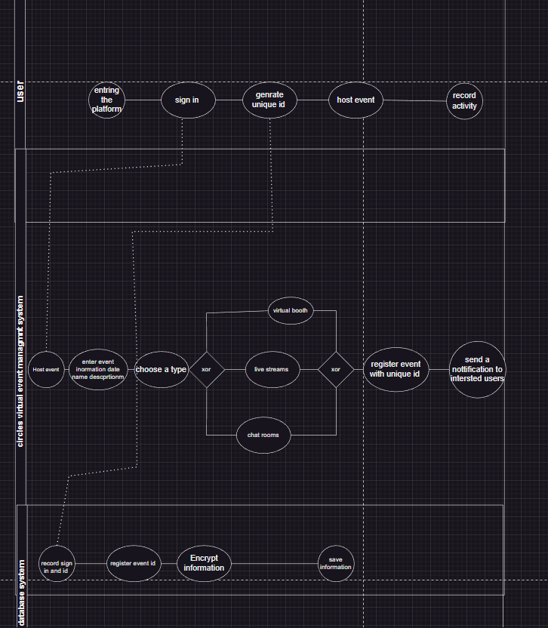

An organization decides to host a virtual event using the platform. The event organizer logs into the system, navigates to the "Create Event" section, and enters details such as event name, date, and description. The system generates a unique event ID. The organizer then defines virtual booths, schedules live streaming sessions, and configures registration options. Once satisfied, the organizer saves the event, triggering automated notifications to potential attendees.